**DE2 Lab 1**

1. Write a program for the following design. The design will display “dE2” (at the three 7-segment LEDs) when SW9 SW8 = “00”, “E2d” when SW9 SW8 = “01”, “2dE” when SW9 SW8 = “10”. The 7-Segment decoder will decode input “00” to “d”, “01” to “E” and “10” to “2”.

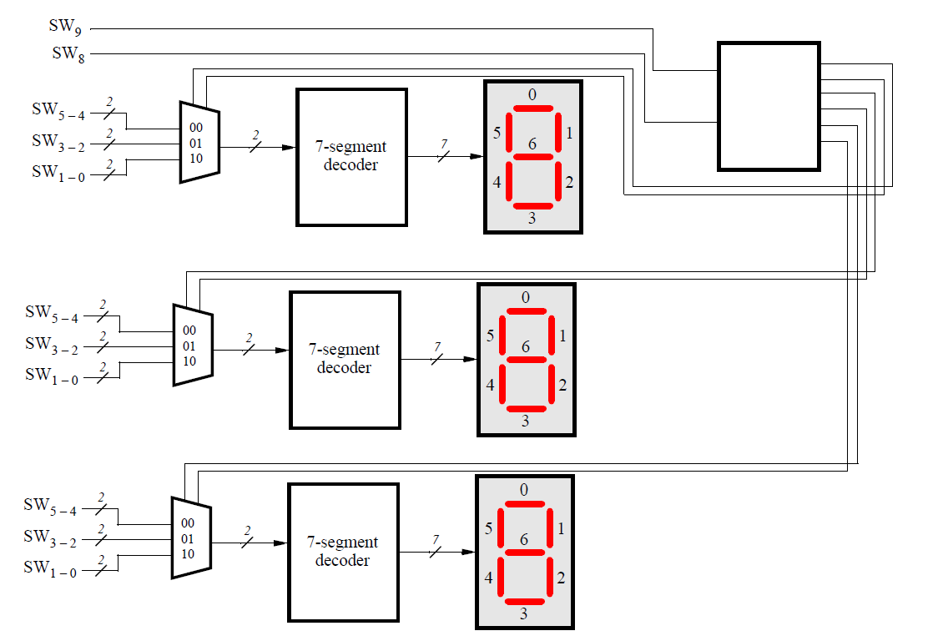

The behaviour of the blank box are as below:

|  |  |  |  |  |  |  |  |
| --- | --- | --- | --- | --- | --- | --- | --- |
| **Input** | | **Output** | | | | | |
| SW9 | SW8 | DECA1 | DECA0 | DECB1 | DECB0 | DECC1 | DECC0 |
| 0 | 0 | 0 | 0 | 0 | 1 | 1 | 0 |
| 0 | 1 | 0 | 1 | 1 | 0 | 0 | 0 |
| 1 | 0 | 1 | 0 | 0 | 0 | 0 | 1 |
| 1 | 1 | 1 | 1 | 1 | 1 | 1 | 1 |

Use Karnaugh Map to get the equation for DECA, DECB, and DECC